Data Types in Java

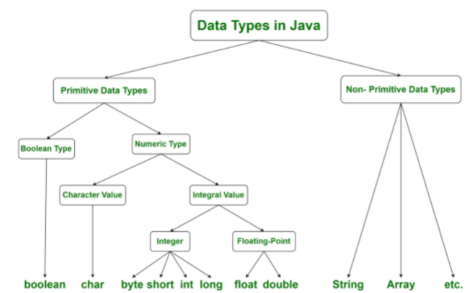
Types of Data Types in Java

- Primitive Data Type – The Pritive data types have single values and they have no special capabilities.

- Non Primitive Data Type – The Non Primitive data type is also known as reference data types as they contain a memory address of a variable value because they won't store the variable directly in memory.

Primitive Data Types and their Properties

Data Type | Numeric Representation | Range of Values | Default Values | Size
boolean | N/A | false and true | FALSE | 1 bit
byte | 8-bit signed | -2⁷ to 2⁷-1 | 0 | 1 byte
short | 16-bit signed | -2¹⁵ to 2¹⁵-1 | 0 | 2 bytes
int | 32-bit signed | -2³¹ to 2³¹-1 | 0 | 4 bytes
long | 64-bit signed | -2⁶³ to 2⁶³-1 | 0L | 8 bytes
float | 32-bit floating point | -1.401298464e-45 to 3.402823466e+38 (positive or negative) | 0.0F | 4 bytes
double | 64-bit floating point | .401298464e-45 to 3.402823466e+38 (positive or negative) | 0.0D | 8 bytes
char | 16-bit unsigned (Unicode Format) | 0 to 2¹⁶-1 | 0 | 2 bytes

Non Primitive Data Types

- String
- Class
- Object
- Interface
- Array

Differences between Primitive and Non Primitive Data Types

Primitive Data Types | Non Primitive Data Types
These are predefined in Java. | These are created by the user and is not defined in Java.
These cannot be used to call methods to perform certain operations. | These can be used to call methods to perform certain operations.  Eg :- String.valueOf()
Primitive data type always have a default value. | Non primitive types can be null.
Primitive type starts with lowercase letter. | Non primitives starts with uppercase letter.  Eg :- String, Object
The size of a primitive type depends on the data type. | Non primitives have the same size.

